Programming Process Program
OBJECTIVE: Write a program that displays the 9 steps of the programming process as shown
below.
The output should contain a “box” around it and have the same formatting as
show in the example below.
View the image below to see how the program’s output should appear.
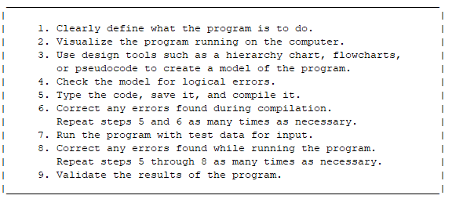
GRADING: (10 points total)
Points Objective
1 Program is able to execute without any errors.
4 Displays some of the steps, but not all 9 steps.
5 Program displays all 9 steps with complete text.
7 Program displays all 9 steps with complete text contained in box.
Includes 3 or more formatting/spelling mistakes.
8 Program displays all 9 steps with complete text contained in box.
Includes 2 formatting/spelling mistakes.
9 Program displays all 9 steps with complete text contained in box.
Includes 1 formatting/spelling mistake.
10 Program displays all 9 steps with complete text contained in box.
Includes no formatting/spelling mistakes.
Program appears similar to image above.

